Social Justice: Colonialism, Post-colonialism,
And Feminism
GSS 270-8 (2018-19)—Thomas and Penn-Goetsch
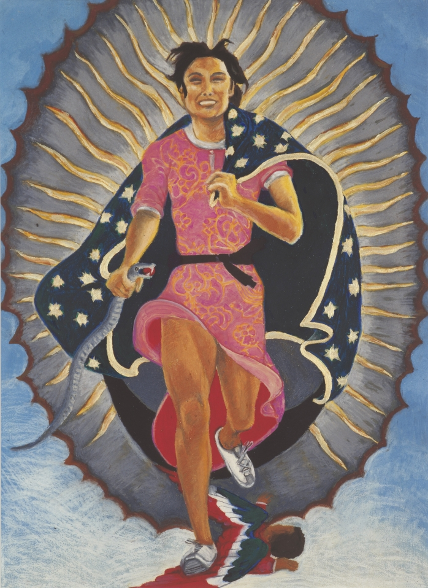
Figure 1. Yolanda López, The Artist as the Virgin of Guadalupe, 2008

“How is identity visible? Why does it matter so much to us how others look? What conditions and informs the way we identify other people visually? Is the notion of ‘identity’ (a modern concept of European origin after all) enough to understand how we attribute meaning to other people and their images? How do we name what we think we see in bodies and images around us and how do we give this named quality meaning and value?”
Amelia Jones,
Seeing Differently: a History and Theory of Identification and the Visual Arts, 2012

“...why would the problem of identification not be, in general, the essential problem of the political?”

Philippe Lacoue-Labarthe
“Transcendence Ends in Politics” in Typography , 1982

In 2016, House Speaker Paul Ryan derided the use of identity politics in contemporary politics that, for him, divide this nation. Yet how do we have diversity without identity or, at the very least, an awareness of difference? This question is precisely at the center of GSS 270, where we will be addressing the intersectionality of third wave feminism throughout the course with an intentional focus on transnational or global perspectives. Our goal is to assist you in articulating ideas, increase your awareness and, thereby, allow you to better enact social change in your futures. In general, social justice fosters the creation and success of institutions that ensure the fair treatment and distribution of costs and benefits to all people, regardless of race, ethnicity, class, religion, gender, and sexual orientation. We will move from the themes of Colonialism and Post-Colonialism to the Civil Rights Movement and Feminisms today.

Inevitably this course will encourage you to consider privilege and oppression from a number of different perspectives. This particular version of GSS 270 will address social justice and injustice in light of the disciplines of politics and the arts. This course will include one trip to Chicago to see a theatre production. There will be one formal paper about the influence of Saartjie Baartman, a midterm, class presentation, and a journal that includes some specific directed assignments. At the end of the course, we hope that you will see a close relationship between the births of the Civil Rights Movement and Feminism during the mid-twentieth century.

Textbooks
(Follows the format for a bibliography in the Chicago Style or Turabian)

Adams, Maurianne, Warren J. Blumenfeld, Carmelita Castañeda, Heather Hackman, Madeline Peters, and Ximena Zúñiga, eds. Readings for Diversity and Social Justice. Fourth ed. New York: Routledge, 2018. (This type of book is called an anthology. If you want to cite a section of this book, you would cite the author and the title of the chapter before listing the books title, the editor, publication city and publisher, date, and the page or page numbers. Assignments from this book will be placed on Moodle.)

Willis, Deborah, ed. Black Venus 2010: They Called Her Hottentot. Philadelphia: Temple University, 2010. (This book is also an anthology.)

Faculty Instructors

Aparna Thomas, Professor of Politics Classroom: 222 McWethy Hall
And Gender, Sexuality and Women’s Studies Class Hours: M-F, 9:30-11 am/1-3 pm
Office: South Hall 205
athomas@cornellcollege.edu (The first day of class meets at 1 pm)
(319) 895-4590

Christina Penn-Goestch, Professor of Art History
Core faculty, Gender, Sexuality and Women’s Studies
Office: McWethy Hall 214
Cpenngoetsch@cornellcollege.edu
(319) 895-4137

Learning Objectives
This course addresses the Education Priorities of Cornell College with a particular focus on Intercultural Literacy by addressing all of the following outcomes:

- Students will gain proficiency in analyzing commentaries on social justice and “reading” visual imagery that assists in understanding the role of privilege and oppression as demonstrated in written and verbal assignments according to the professional standards and style of the disciplines of politics and art history (Communication, Reasoning, and Intercultural Literacy).
- The class integrates the recognition of particular art works, themes, and issues as a reflection of individual cultures and time periods. This course will therefore expect that students will be able to recognize most art works or themes as coming from a particular group or community and to be able employ information literacy tools in order to assist in this process (Knowledge, Inquiry, and Intercultural Literacy).
- Specifically all students will be able to articulate at least some of the effects of racism, sexism, and discrimination as related to themes addressed by communities in the United States and throughout the world (Knowledge and Intercultural Literacy).
- This awareness should result in more ethical choices and a greater understanding of how businesses and public institutions influence the development and sustainability of communities (Knowledge, Ethical Behavior, and Citizenship).

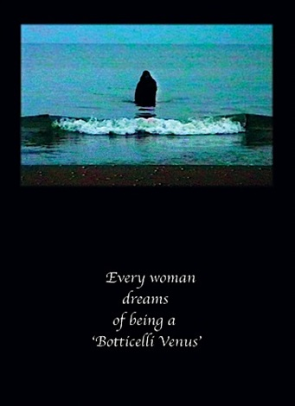
Course Evaluation

Class Participation (Thomas/Penn-Goetsch) 20%
Midterm—2 parts (Thomas/Penn-Goetsch) 20%
Class Presentation (Thomas) 15%
Directed Research Paper (Penn-Goetsch) 15%
Journal (Thomas/Penn-Goetsch) 30%

Additional Accommodations

Students who need accommodations for learning disabilities must provide documentation from a professional qualified to diagnose learning disabilities. For more information see
cornellcollege.edu/disabilities/documentation/index.shtml

Students requesting services may schedule a meeting with the disabilities services coordinator as early as possible to discuss their needs and develop an individualized accommodation plan. Ideally, this meeting would take place well before the start of classes. At the beginning of each course, the student must notify the instructor within the first three days of the term of any
Figure 2. Ghazel, Venus, Still from Me, 1997-2000, Video Installation.
accommodations needed for the duration of the course

Class Participation

Your class participation score is directly linked to how often you actually participate in class; however, there is an attendance component to the score. If you attend on a regular basis (missing no more than two class sessions at most) but do not participate, you would receive a “C” for this portion of your grade. On the other hand, your grade will decrease based on lack of attendance as well. We do expect you to contribute regularly to the class conversation.

Please make sure to show up to class on time and prepared to discuss the readings. Make sure to let us know if you are unclear about assignments or you’re uncertain about how to proceed.

You may use a laptop to take notes in class, but do not become involved with emails, web research unless directed to do so, or Facebook while in class. Avoid using the cell phone for emails or text messages. Please consider turning off your cell phones and putting them away.

How to get the most out of class discussions
Classroom participation is a key requirement in this course. The most important policy is to be polite and respectful. Consider other people’s feelings. Every person in this class is equally responsible for the success of the course. Here are some tips to make most of your experience in this class:
1. Enter into class activities with enthusiasm
2. Openly share related experiences
3. Respect the views of your classmates
4. Be patient with others
5. Be honest and sincere about your thoughts and feelings
6. Restrict discussions to relevant topics
7. Try not to monopolize discussions

A Few Basic Ground Rules
One of the premises of gender studies is that living and learning are inseparable, that there is a relationship between our experiences as women and men and how we see the world. It is essential in this course that we discuss our personal experiences as they relate to issues we are addressing in class. Therefore, we have established three fundamental understandings:

1. You are under no pressure to share personal experiences on a particular topic if you don't want to.

2. You will not share the personal experiences revealed by other members of this class to anyone outside of class. Anyone violating this expectation of trust and confidentiality will receive a failing grade.

3. Many of the issues we will discuss involve our personal and political philosophies. There is no reward and no penalty for having a particular set of beliefs. It is only important that we be clear about what we believe and why.

This is what we will be considering when evaluating your participation:

quantity: one or two token comments per two-and-one-half-hour class is not adequate.

quality: demonstrate that you're thinking, both when reading and preparing for class and during class. Talking without preparation or thinking, or because you like the sound of your own voice, won't cut it either.

preparation: We won't assume you've read. You have to show us you have.

Individual Presentation

The course is structured as a seminar course, which means the style should be relaxed, open, and participatory. Students will be responsible for leading class discussions in small groups at least once during the block. Chapters from the books will be assigned to pairs of students. Discussion leaders should plan material for about ½ hour. The goal is to understand the major themes from the readings and come up with discussion questions for the rest of the class. Possible topics for this assignment are highlighted with red on the syllabus.

Reflective Journals

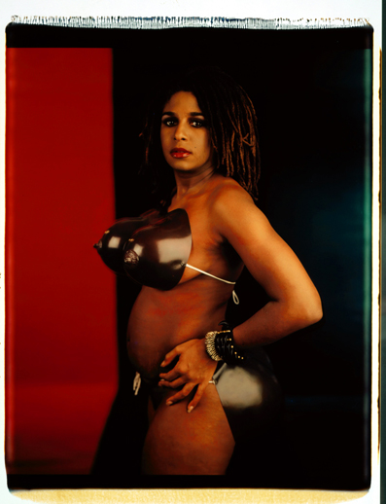
The main goal of journal entries is to provide students an opportunity to comment, observe, question, and critique the readings, films, and class discussions. We want you think about ways in which all of the topics and themes intersect with social justice. Journal entries might include personal reflections, but we are looking for thoughtful responses to class themes. You are required to submit at least 5 journal entries per week. The journal entries are to be a minimum of one page- typed, double- spaced. Furthermore, some of the entries are required topics. These include film comparisons for “The Secrets” and “Fire” as well as “Mississippi Masala” and “Watermelon Woman.” One of the journal entries must address how the performance of “Hamilton” addresses social injustice (Dec. 5). Two additional entries should comment on art that addresses social justice or (in)justice. Please feel free to ask Penn-Goetsch about ideas. The journals count for 30% of the final grade and all your entries are due on the last day of the class.

Directed Research Paper (5-8 pages)

This is an assignment, where I provide you with strong sources for writing a research paper about Saartjie (Sarah) Baartman’s history and the ramifications her life and the racialist theories that surrounded that life as well as how the arts have responded her central role in history. By arts, I am talking about the visual arts, theatre and creative writing. The thesis and particular focus of your essays should include some of the source materials listed, but the choice is up to you. Nevertheless, you must apply at least six of the sources listed below. Most of the material is included in Black Venus, 2010, as it is an anthology of multiple essays. If you want to use a chapter that I have not listed as one of the six, you may. You are not required to summarize the entire article or poem in this paper. Instead, you just must manage to cite six of the works listed in the footnotes and bibliography. Please remember that you must include the author’s name and the title of the chapter employed in any footnote along with the title of the book, editor, publication information, and exact page numbers.
Figure 3. Lyle Ashton Harris and Renee Cox, Venus Hottentot, 2000, 1994

Bibliography of Sources (You must employ at least six of these sources; however, you can add other source material to the six if you choose to do so. Remember that footnote entries are listed a little differently than bibliographic entries.)

Alexander, Elizabeth, “Prologue.” In Black Venus 2010: They Called Her Hottentot, edited by Deborah Willis, 1-2. Philadelphia: Temple University, 2010.

Bass, Holly. “crucifix.” In Black Venus 2010: They Called Her Hottentot, edited by Deborah Willis, 68. Philadelphia: Temple University, 2010.

Cobb, William Jelani. “The Hoodrat Theory.” In Black Venus 2010: They Called Her Hottentot, edited by Deborah Willis, 210-212. Philadelphia: Temple University, 2010.

Collins, Lisa Gail. “Historic Retrievals: Confronting Visual Evidence and the Imaging of Truth.” In Black Venus 2010: They Called Her Hottentot, edited by Deborah Willis, 71-86. Philadelphia: Temple University, 2010.

Daniels, J. Yolande. “Exhibit A: Private Life without a Narrative.” In Black Venus 2010: They Called Her Hottentot, edited by Deborah Willis, 62-67. Philadelphia: Temple University, 2010.

Ford, Kianga K. “Playing with Venus: Black Women Artists and the Venus Trope.” In Black Venus 2010: They Called Her Hottentot, edited by Deborah Willis, 96-106. Philadelphia: Temple University, 2010.

Fortini, Amanda. “No Filter: An Afternoon with Kim Kardashian.” Photos by Jean-Paul Goude. Paper Magazine, Jan. 14, 2015, n.p. (This is an article in a popular magazine. On Order at Cole Library)

Gilman, Sander. “The Hottentot and the Prostitute: Toward and Iconography of Female Sexuality.” In Black Venus 2010: They Called Her Hottentot, edited by Deborah Willis, 15-31. Philadelphia: Temple University, 2010.

Goude, Jean-Paul. Jungle Fever. New York: Xavier Moreau, Inc., 1982. (On order at Cole Library)

Harris, Michael D. “Mirror Sisters: Aunt Jemima as the Antonym/Extension of Saartjie Bartmann.” In Black Venus 2010: They Called Her Hottentot, edited by Deborah Willis, 163-179. Philadelphia: Temple University, 2010.

Jackson, Linda Susan. “little sarah.” In Black Venus 2010: They Called Her Hottentot, edited by Deborah Willis, 144. Philadelphia: Temple University, 2010.

Jones, Kellie. “A.K.A. Saartjie: The ‘Hottentot Venus’ in Context, 1998/2004.” In Black Venus 2010: They Called Her Hottentot, edited by Deborah Willis, 126-143. Philadelphia: Temple University, 2010.

Kornweibel, Karen Ruth. “Race, Spectacle, and Complicity in Suzan-Lori Parks’s Venus.” South Atlantic Review 74 (2009): 64-81. JSTOR. (This is a journal article from a database.)

Magubane, Zine. Which Bodies Matter? Feminism, Post-Structuralism, Race, and the Curious Theoretical Odyssey of the ‘Hottentot Venus.’” In Black Venus 2010: They Called Her Hottentot, edited by Deborah Willis, 47-61. Philadelphia: Temple University, 2010.

Mitchell, Robin. “Another Means of Understanding the Gaze: Sarah Bartmann in the Development of Nineteenth-century French National Identity.” In Black Venus 2010: They Called Her Hottentot, edited by Deborah Willis, 32-46. Philadelphia: Temple University, 2010.

Parks, Suzan-Lori. Venus. New York: Theatre Communications Group, 1997. (Reserve)

Singer, Debra S. “Reclaiming Venus: The Presence of Sarah Bartmann in Contemporary Art.” In Black Venus 2010: They Called Her Hottentot, edited by Deborah Willis, 87-95. Philadelphia: Temple University, 2010.

Wallace, Michele. “The Imperial Gaze: Venus Hottentot, Human Displays, and World’s Fairs.” In Black Venus 2010: They Called Her Hottentot, edited by Deborah Willis, 149-154. Philadelphia: Temple University, 2010.

Willis, Deborah. “The Notion of Venus.” In Black Venus 2010: They Called Her Hottentot, edited by Deborah Willis, 3-11. Philadelphia: Temple University, 2010.

Young, Jean. “The Re-objectification and Re-commodification of Saartje Baartman in Susan-Lori Parks’s Venus.” African American Review 31 (1997): 699-708. JSTOR. (This is a journal article from a database.)

Procedures (The Quirks of Art History Papers)

- Completed papers should be double-spaced and submitted by 5 pm on Tuesday, December 6.
- All papers must include figure pages with the images that are discussed in your papers. The first reference to an image should be referred to as (Fig. 1) and come just before the punctuation mark at the end of the sentence or phrase in the body of the text. Place the critical information of artist, title, medium, and date underneath the image itself included at the back of the paper. In art history, we usually do not cite this type of information in a footnote or endnote. We include a reproduction of the image. Also titles of works of art should not be listed within quotation marks. Either underline or use italics for titles of works of art.

Scanned or inserted (pasted from the web) illustrations should be attached to the very back of your paper. Number illustrations consecutively and mention the figure numbers within the body of your text.

- Omit unrelated biographical material and focus on the works of art for the paper. Avoid lengthy quotations form secondary sources. The paper should reflect your views, but they must demonstrate an informed perspective. Previous scholarship should be consulted and credited with footnotes or endnotes. Locate the bibliography just before the figure pages at the back of your paper. The notes and bibliography should follow the model of the Chicago Manual of Style for the Humanities or Turabian. You need footnotes! Remember that this style is different from the Chicago Style for the Social Sciences that uses parenthetical notations for citations.
- Whenever you make reference to an idea, position, or argument of a writer, make sure to cite the source with a specific page number in a footnote. This is quite different from the APA style for papers. Internal citations are required for more than just direct quotations. Please ask if you have questions. Plagiarism is not acceptable and will result in a failing grade. Lack of awareness of how and when to cite a source is not an excuse.

Students often wonder about when to cite sources with parenthetical notations, footnotes, or endnotes. This concern is justified, as plagiarism is a serious offense. I reserve the right to fail any paper, even if the plagiarism is due to carelessness alone. The original source of the word implies the stealing of slaves or children, but we are talking about the stealing of ideas in an academic context. I will upload a style sheet on Moodle. You may want to check out http://owl.english.purdue.edu/handouts/research/r_plagiar.thml. There are three primary areas that should include some form of a citation.

1. If you use the exact words of an author, use a citation. Place the words within quotation marks.
2. If you draw upon the ideas, arguments, or observations of others, use citations.
3. If you include facts not widely available or known, use citations.

Some scholars also use a citation, when they want to direct the reader toward useful information on a given subject or to explain an argument further. As you cite sources, make sure to go to the original source for an idea whenever possible. If you follow these guidelines, you will be well prepared for future research projects in the Humanities.

Cornell College expects all members of the Cornell community to act with academic integrity. An important aspect of academic integrity is respecting the work of others. A student is expected to explicitly acknowledge ideas, claims, observations, or data of others, unless generally known. When a piece of work is submitted for credit, a student is asserting that the submission is her or his work unless there is a citation of a specific source. If there is no appropriate acknowledgement of sources, whether intended or not, this may constitute a violation of the College’s requirement for honesty in academic work and may be treated as a case of academic dishonesty. The procedures regarding how the College deals with cases of academic dishonesty appear in The Compass, our student handbook, under the heading “Academic Policies – Honesty in Academic Work.”

Rubric for a Paper that Addresses an Intermediate-level Assignment in Art History
Categories include the following:

- Thesis
- Logic and Understanding of Material
- Structure of the Argument (You must have a “map of topics” somewhere in your introduction. Ask if you do not know what I mean by this map.)
- Citations

A | B | C | D
1. thesis is compelling, focused, and introduces an innovative idea | 1. thesis is clear, but may have shifting focus or lack specificity | 1. thesis is apparent, but may have shifting focus or lack specificity | 1. thesis is not obvious, but there is a topic in place
2. organizes ideas logically within paragraphs and connects them with highly effective transitions  employs a logically consistent organization with topic sentences that guide the reader through the argument  develops ideas clearly and demonstrates a thorough awareness of the material read. | 2. develops unified and coherent ideas within paragraphs with generally adequate transitions  employs a clear overall organization that demonstrates a reasonable awareness of the material read | 2. organizes ideas in paragraphs that are not necessarily connected  shows a basic awareness of the material read | 2. includes an uneven and/or ineffective overall organization  demonstrates a minimal awareness of the material read
3. clearly addresses a claim or observation with a structure that follows the “map” outlined in the introduction | 3. addresses evidence that follows the “map” outlined in the introduction | 3. addresses evidence, but the structure does not follow the “map” outlined in the introduction | 3. addresses evidence poorly with no structure apparent in the introduction
4. research is supported, correctly quoted, paraphrased, and cited | 4. research is supported, adequately quoted, paraphrased, and cited | 4. research is supported, but incorrectly quoted, paraphrased, or cited | 4. research is inaccurately presented.

Tentative Syllabus
(The main goal of the course is not to cover every single image and text listed, but to come to better understand some of the issues surrounding the study of social justice and injustice. Each class is adjusted toward the needs and pace of the individuals involved. This class also is offered during a period when faculty are involved with faculty searches and adjustments to the class schedule are inevitable. )

Class typically meets at 9:30 a.m. and 1:00 p.m.

Colonialism

Monday, Nov. 26 Introduction: Meanings of Social Justice
We meet at 1 pm the first day.
What is social justice and (in)justice? How do images comment or engage these themes?
Readings on Social Justice: Conceptual Frameworks (Chap. 8, pp. 59-64, from Readings for Diversity and Social Justice- on Moodle)
Hannah Gadsby, “Nanette,” 2018
Mieke Bal, “Reading Art?” in Generation and Geographies in the Visual Arts: Feminist Readings, ed. Griselda Pollock (London: Routledge, 1996) Chap. 2, 25-41. (Moodle)

Tuesday, Nov. 27 Colonialism and Response
AM: Readings on Social Justice: Conceptual Frameworks (Chaps. 1-4 and 7; pp. 7-26 and 49-58, from Readings for Diversity and Social Justice- on Moodle)

PM Patricia Leighten, “The White Peril and L’Art nègre: Picasso, Primitivism, and Anticolonialism,” Art Bulletin 72 (1990): 609-630. JSTOR.

Wednesday, Nov. 28 The Female Body
AM Sander Gilman, “The Hottentot and the Prostitute: Toward and Iconography of Female Sexuality,” in Black Venus 2010: They Called Her Hottentot, ed. Deborah Willis (Philadelphia: Temple University, 2010), 15-31.

PM: Racism (Chaps. 9-101, pp. 74-102, from Readings for Diversity and Social Justice- on Moodle)

Thursday, Nov. 29 Orientalism

AM Introducing Edward Said
Edward Said (see Youtube interview) https://www.youtube.com/watch?v=fVC8EYd_Z_g

PM Linda Nochlin, “The Imaginary Orient,” in Race-ing Art History: Critical Readings in Race and Art History, ed. Kymberly N. Pinder (New York: Routledge, 2002), 69-85. (Moodle)

Friday, Nov. 29 Double Vision
AM The Art of Shirin Neshat
PM Women without Men, directed by Shirin Neshat (New York: IndiePix Films, 2010), DVD.

Post Colonialism and Civil Rights

Monday, Dec. 3 Post Colonial Identities
AM (Chaps. 15-19 and Chap. 22; pp. 109-128 and 138-146, from Readings for Diversity and Social Justice- on Moodle)
Hagiwara Hiroko, “Comfort Women, Women of Conformity: The Work of Shimada Yoshiko,” in Generation and Geographies in the Visual Arts: Feminist Readings, ed. Griselda Pollock (London: Routledge, 1996) Chap. 14, 253-265. (Moodle)

PM I Can Speak. directed by Hyun-seok Kim (Seoul: Echelon Productions, Inc. and Myung Films, 2017)

Tuesday, Dec 4 Saartjie Bartmann
AM Artists’ Responses

PM Lisa Gail Collins, “Historic Retrievals: Confronting Visual Evidence and the Imaging of Truth,” in Black Venus 2010: They Called Her Hottentot, ed. Deborah Willis (Philadelphia: Temple University, 2010), 71-86.
Kellie Jones, “A.K.A. Saartjie: The ‘Hottentot Venus’ in Context, 1998/2004,” In Black Venus 2010: They Called Her Hottentot, ed. Deborah Willis (Philadelphia: Temple University, 2010), 126-143.

Wednesday, Dec. 5 Trip to Chicago for Hamilton Matinee
Leave from the Commons at 8 am and return by 11 pm. Bring money for a fast food dinner on the way home.
Additional reading will be provided.

Thursday, Dec. 6 Social Justice and the Theatre (Paper Due)
AM No Class
PM Professor Janeve West leads a discussion

Friday, Dec. 7 AM Midterm Exam 10 am to 12 noon
PM Mississippi Masala, directed by Mira Nair (Culver City, CA : Sony Pictures, 1991), DVD.

Feminisms

Monday, Dec. 10 Sexism
AM Sexism and Reproductive (In)Justice (Chaps. 63-64, and 80; pp.359-367, and 415-419, from Readings for Diversity and Social Justice- on Moodle)
Additional reading will be provided.
PM A Girl in the River: The Price of Forgiveness, directed by Sharmeen Obaid-Chinoy (New York: HBO, 2015).

Tuesday, Dec. 11 The Virgin of Guadalupe
AM Artists Respond
PM Gloria Anzaldua (Chap.14 and Chap. 136; pp. 109-128 and 637-639, from Readings for Diversity and Social Justice- on Moodle)

Wednesday, Dec. 12 Social Justice and Religious Oppression

AM Rev. Dr. Catherine Quehl-Engel (tentative)
Nadya Tolokonnikova. “Commit an Art Crime,” in Read & Riot: A Pussy Riot Guide to Activism (New York: HarperOne, 2018), 75-93. (Moodle)
PM The Secrets, directed by Avi Nesher (Tel Aviv, Israel: Artomas Communications, Metro Communications, Tu Vas Voir, 2007—Israel release date, 2009—US release date), DVD. 12:50 to 3 pm.

Thursday, Dec. 13 Heterosexism
AM Queer Artists and Activism
(Chaps. 66, 75, and 82; pp. 367-373, 398-400, and 425-429 from Readings for Diversity and Social Justice- on Moodle)

PM Fire, directed by Deepa Mehta (India and Canada, Trial by Fire Films Inc., Kaleidoscope Entertainment, 1996), DVD.

Friday, Dec. 14 Trans+ Oppression
AM (Chaps74, 76, 83 and 93; pp. 394-398, 400-403, 429-432, and 459-461, from Readings for Diversity and Social Justice- on Moodle)

PM Discussion Continues

Monday, Dec. 17 AM Popular Culture—Returning to Kim Kardashian

Michael Harris, “Mirror Sisters: Aunt Jemima as the Antonym/Extension of Saartjie Bartmann.” in Black Venus 2010: They Called Her Hottentot, ed. Deborah Willis (Philadelphia: Temple University, 2010), 163-179.
William Jelani Cobb, “The Hoodrat Theory,” In Black Venus 2010: They Called Her Hottentot, ed. Deborah Willis (Philadelphia: Temple University, 2010), 210-212.

Cavan Sieczlcowski, “Feminist Activist Says Beyoncé is Partly ‘Anti-Feminist’ and ‘Terrorist,’” Huffington Post, May 9, 2014. http://www.huffingtonpost.com/2014/05/09/beyonce-anti-feminist_n_5295891.html

Check out this NPR story on Beyoncé: “How Sweet It Is To Be Loved By You.” http://www.npr.org/sections/therecord/2014/03/17/258155902/how-sweet-it-is-to-be-loved-by-you-the-beyhive?utm_source=npr_newsletter&utm_medium=email&utm_content=20160410&utm_campaign=npr_email_a_friend&utm_term=storyshare

PM Watermelon Woman, directed by Cheryl Dunye (New York: First Run Features, 1992), DVD. 12:30 to 3 pm

Tuesday, Dec. 18 Making a Plan for the Future

AM Nicolas Lampert, “Come Let Us Build a New World Together,” A Peoples Art History of the United States (New York: The New Press, 2013), 188-198. (Moodle)
Carrie Mae Weems, “Can an Artist Inspire Social Change?” National Museum for Women in the Arts, Fresh Talk, November 15, 2015. https://nmwa.org/events/fresh-talk-carrie-mae-weems

PM Patricia Hill (Chap. 132; pp. 615-620, from Readings for Diversity and Social Justice- on Moodle)

Wednesday, Dec. 19 AM Last Class Session (Tentative)
Journals – Due at Noon

“The magic of art is that it elevates your voice and amplifies it. Sometimes it happens literally, with a microphone and speakers. Art is a miracle-making machine. Art opens up alternative realities, and that’s extremely helpful when we have a crisis and multiple failures of the political imagination.”
--Nadya Tolokonnikova, Read & Riot: A Pussy Riot Guide to Activism, 2018.

Joseph P. Williams, “Paul Ryan for President? “ US News and World Report, April 8, 2016, http://www.usnews.com/news/articles/2016-04-04/paul-ryan-for-president.

